# CS 255 System Design Document Template

This template lays out all the different sections that you need to complete for Project Two. Each section has guidance to prompt your thinking. You will need to continually reference the interview transcript as you work to make sure that you are addressing your client’s needs. There is no required length for the final document. Instead the goal is to complete each section based on what your client’s needs are. Remove this note when you are finished, and replace all bracketed text with the relevant information.

## UML Diagrams

### UML Use Case Diagram

### UML Activity Diagrams

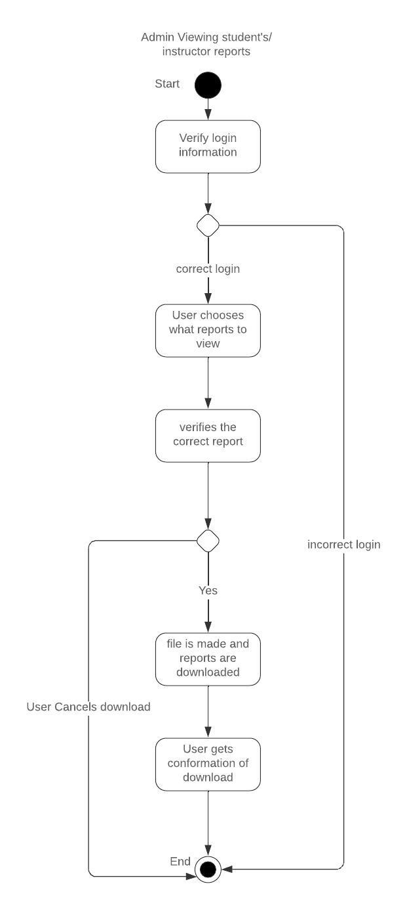

### UML Sequence Diagram

### UML Class Diagram

## Technical Requirements

*The technical requirements for the DriverPass system ensure functionality, scalability, and security. Client-side devices must be internet-enabled, with web browsers like Chrome or Safari, while the cloud-based server infrastructure will ensure 24/7 availability, scalability, and disaster recovery. The backend will use Python, Java, or Node.js with frameworks like Django or Spring Boot, and PostgreSQL or MySQL for data management. The frontend will leverage React.js or Angular for a responsive, mobile-compatible interface, supported by cloud platforms such as AWS or Azure for hosting and authentication services.*

*The system will include tools like Selenium for testing, JIRA for project management, and New Relic for performance monitoring. It will integrate with DMV systems for updates and employ security measures like SSL/TLS, multi-factor authentication, and brute force protection. Development tools like Git and IDEs such as Visual Studio Code will streamline collaboration. Customer support will be managed with Zendesk, and Google Analytics will provide user insights. These requirements ensure DriverPass is efficient, reliable, and user-friendly.*